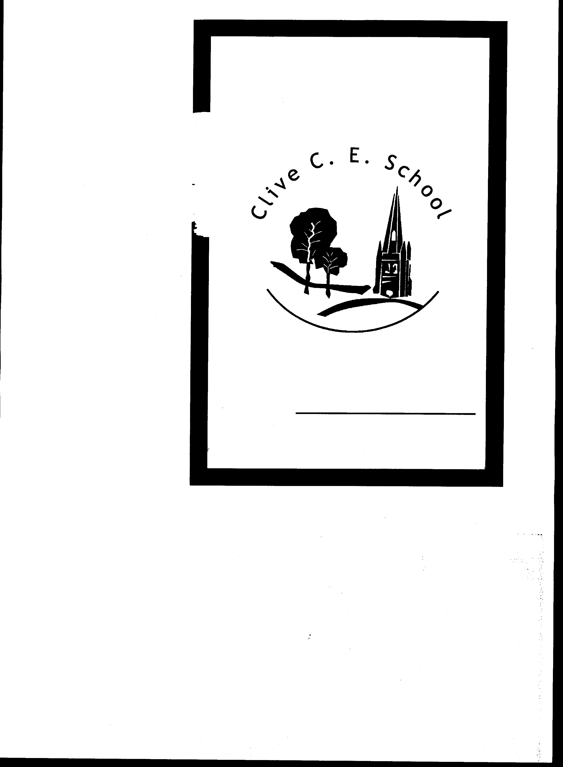Clive C E Primary School
The Hill
Grinshill
Shrewsbury
SY4 3LF
Telephone / Fax: 01939 220385
Email: admin@clive.shropshire.sch.uk

Website: www.clivecofeprimaryschool.co.uk

Headteacher: Miss Mary A Lucas

13 November 2017

Changes at Clive School

Dear Parents,

It is with sadness that I have to tell you that Miss Lucas will be retiring at the end of this academic year (July 2018). Miss Lucas has been in post for almost 20 years, and throughout that time has shown outstanding commitment to the education of hundreds of children and to the growth and development of the school. She will be hugely missed, and we will be formally marking her retirement nearer the time.

In order to ensure that life at school continues with as little disruption as possible, the Governors are considering a number of options with regard to finding a replacement for Miss Lucas. I hope to be in a position to let you know the future arrangements by Christmas.

I should also let you know that I am now Chair of Governors, and Jane Thompson is now Vice-Chair. If you need to contact either of us, my e-mail address is markheynon@gmail.com, and Jane’s is janethompsonsy1@gmail.com.

I will let you know as soon as there is further news.

With best wishes,

Mark Haines-Eynon



